Leo Zhuolan Zhang

I want to make a small automobile which can be controlled by the phone. the small car connected with the smart phone and when the position of the phone changes, the car will follow the change of the phone. For example, when I move my phone to the right, the car will turn right. One of the goal of this project is to satisfy my childhood dream. it is wonderful to control a car when your body move. Also, in the future, if human’s body can control the automobile. It will so cool. In the reality, people can use this program to send the package. And everything can be control in a distance. Moreover, it feels more intimate with machine if a part of our body can control it.

For my prototype of this big goal, I want to show the possibility of human interacts with automobile. I will use some wood to build the small car and install the Arduino on the bottom part of my car. I might get the Bluetooth signal component or the wifi signal component to connect to my phone. I will also have X,Y,Z sensor being installed in the Arduino which is connected on my phone. so when X,Y,Z sensor read the number. The car will function.

The challenge is that I have never done this kind of projects before. Also, even I have a thought to make it work. But I don’t know how to write the code for my car. And I don’t know will X,Y,Z works can how the car to function when those number change. Everything is just my thoughts. 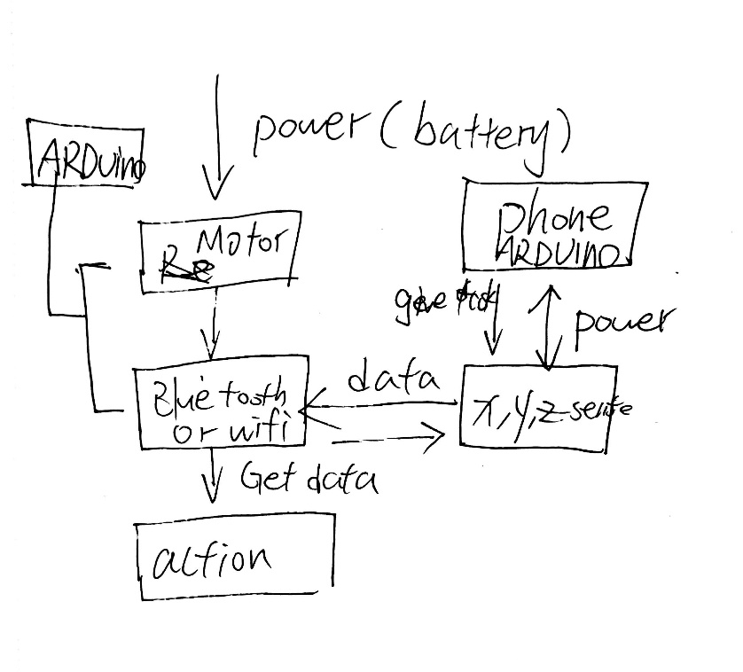

Week 1: Write Proposal

Week 2; build a car

Week 3: discuss the way to connect

Week 4 : adjust

Week 5: present